5 Rounds combat encounter simulation
- I will be creating a machine learning algorithm to estimate the difficulty of pathfinder2e monster combat encounters based on the party character builds. This simulation will capture the real-world decisions made for 6 characters (3 heroes and 3 monsters) in a 6x6 grid battle map. The main decisions should be based on optimizing damage output and reducing the length of the combat for each side- so action decisions should be combat-focused (although support decisions are acceptable for strategy decisions!)
- The purpose of this survey is to record the action choices made for each character during a 5-round monster encounter. In each paragraph, I will need the information of what actions from the given character spreadsheet (see email for attachments) you would choose for each combat round. Feel free to specify any action options not listed on the action list (i.e. general actions like trip/grapple/sweep are not included, but would be valid options).
- In each response, also define which creature is the target when applicable, and the order of the actions (3 actions/round) so multiple-attack-pentaly will be taken into account.
- It is not required to keep track of HP or encounter progress, mostly to get an idea of strategic decision making. However, if you do want to roll dice and keep track of damage, feel free! Leave a note at what round creatures drop (if applicable), and that will be helpful for training the model as well.
Online resource for pathfinder 2e mechanics, if needed : https://www.aonprd.com/

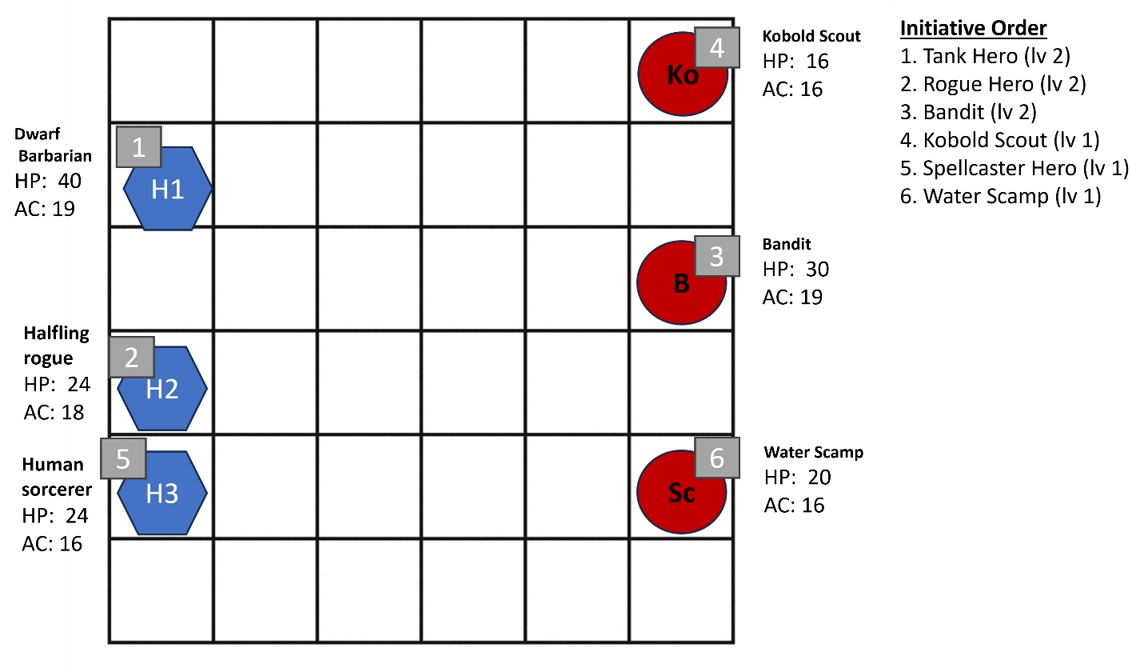
Round 1
- Dwarf Barbarian [starts with greataxe]
  - –
  - –
  - –
- Halfling Rogue [starts with surprise attack and dual wield rapier/dagger]
  - –
  - –
  - –
- Bandit [starts with machete and free hand]
  - –
  - –
  - –
- Kobold Scout [starts with shortsword, no sneak attack]
  - –
  - –
  - –
- Human Sorcerer [start with 2 free hands]
  - –
  - –
  - –
- Water Scamp [starts with 2 free hands]
  - –
  - –
  - –

Round 2
- Dwarf Barbarian
  - –
  - –
  - –
- Halfling Rogue
  - –
  - –
  - –
- Bandit
  - –
  - –
  - –
- Kobold Scout
  - –
  - –
  - –
- Human Sorcerer
  - –
  - –
  - –
- Water Scamp
  - –
  - –
  - –

Round 3
- Dwarf Barbarian
  - –
  - –
  - –
- Halfling Rogue
  - –
  - –
  - –
- Bandit
  - –
  - –
  - –
- Kobold Scout
  - –
  - –
  - –
- Human Sorcerer
  - –
  - –
  - –
- Water Scamp
  - –
  - –
  - –

Round 4
- Dwarf Barbarian
  - –
  - –
  - –
- Halfling Rogue
  - –
  - –
  - –
- Bandit
  - –
  - –
  - –
- Kobold Scout
  - –
  - –
  - –
- Human Sorcerer
  - –
  - –
  - –
- Water Scamp
  - –
  - –
  - –

Round 5

- Dwarf Barbarian
  - –
  - –
  - –
- Halfling Rogue
  - –
  - –
  - –
- Bandit
  - –
  - –
  - –
- Kobold Scout
  - –
  - –
  - –
- Human Sorcerer
  - –
  - –
  - –
- Water Scamp
  - –
  - –
  - –

